Project plan: Pass The Ball

**By:** Simeon Markov

**Institution:** Fontys UAS

**Course/Class:** ICT/EN08

**Date:** 2025-10-13

**Introduction**

This document presents the project’s objectives and goals by giving a scope of realization. It also contains the project’s plan phase, illustrating the allocated time for the different phases and the planned deadline as well. Moreover, the document imposes questions on how the platform could ensure safe environment for the users and how it could handle more users.

Project overview

**Pass The Ball** is a social platform, trying to reduce the tension of finding a sports mate to train with. People could join their favorite sport group, chat with like-minded people, post tweets and arrange events. Moreover, admins could create groups, accept/reject user’s invitation to that group as well as delete certain posts that violate the group’s rules. The goal of this project is to motivate different groups of people to be more physically proactive through the help of modern technologies.

*Keywords:* social network, community, sports.

# Objectives

Designing and implementing a working version of the social platform within four weeks, covering at least three ICT topics, for in-depth analysis, design, and implementation.

## Points for the project

* *A Unified Social & Activity Hub:* A single platform that combines social networking features (profiles, feeds, messaging) with practical activity tools (events creation, RSVPs, scheduling).
* *Interest Discovery:* Users must be able to find other enthusiasts and activities/groups (the platform shows related content).
* *Seamless Activity Management:* Simplifying the process of creating, promoting, and managing sports events/posts.
* *Community-Driven Content:* Features for users to upload photos/videos, write comments and post articles.
* *Inclusivity and Safety:* Tools to create private groups (men/women only sports clubs), verified profiles, ensuring a safe and welcoming environment.

### Main Questions

1. How can an online social platform enhance the way individuals connect and engage in sporting activities?
2. How could different groups, content/posts be moderated, ensuring inoffensive environment.
3. What could be done to ensure stability in performance and data overload.

**Learning outcomes & covered topics**

**Learning Outcomes**

* Develop the ability to design and implement user management systems, including secure registration, profile customization, and robust authentication processes for social platforms.​
* Gain proficiency in employing modern web development frameworks and architectural patterns, specifically Laravel and Vue.js, to create scalable, responsive, and cross-platform social network applications.​
* Demonstrate competence in integrating real-time and location-based features, such as dynamic event feeds, calendar syncing, and map-based activity discovery, to enhance user engagement and experience.​
* Acquire skills for building and optimizing relational and search databases (MariaDB, Elasticsearch), supporting complex queries, advanced social search, and scalable social network data processing.

**Covered Topics**

* Software engineering, Media design, Artificial Intelligence.

### Planning

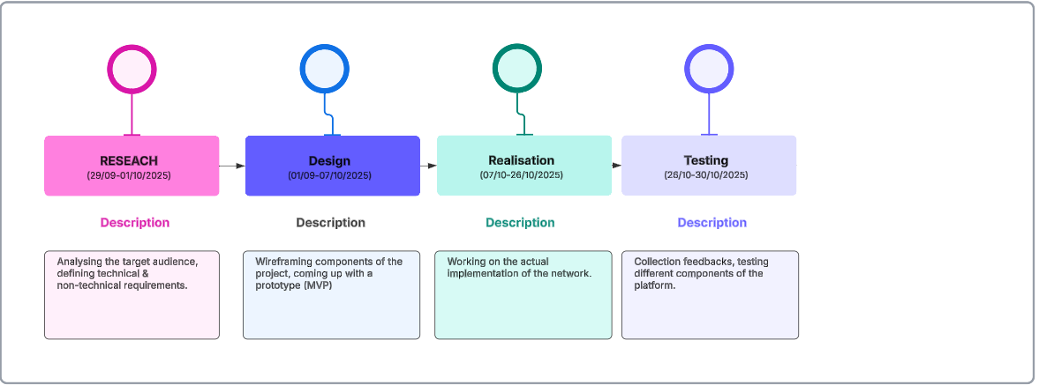LucidChart software for creating the timetable was used.

Figure : Timetable illustrating the different phases

Breakdown:

(29/09-01/10): Analyzing stakeholders, user stories, coming with suitable functional, technical, non-technical requirements concerning the project.

(01/10-07/10): Writing the design document, design planning, wireframing of components and coming up with a working prototype.

(07/10-26/10): Implementing app’s major functionalities like authentication, user profile settings, files, posts/tweets upload, commenting, liking, sharing, etc. as well as security concerns (roles, 2fa-auth).

(26/10-30/10): Gathering feedback from potential users, monitoring queries execution time, unit testing on code segments.